 |  | E
WIPO/GRTKF/IC/36/10
ORIGINAL: English
DATE: June 26, 2018

Intergovernmental Committee on Intellectual Property and Genetic Resources, Traditional Knowledge and Folklore

Thirty-Sixth Session
Geneva, June 25 to 29, 2018

The Economic Impact of Patent Delays and Uncertainty: U.S. Concerns about Proposals for New Patent Disclosure Requirements

Document submitted by the Delegation of the United States of America

INTRODUCTION

- On June 26, 2018, the International Bureau of the World Intellectual Property Organization (WIPO) received a request from the Delegation of the United States of America, to submit “The Economic Impact of Patent Delays and Uncertainty: U.S. Concerns about Proposals for New Patent Disclosure Requirements” for discussion by the Thirty-Sixth Session of the Intergovernmental Committee on Intellectual Property and Genetic Resources, Traditional Knowledge and Folklore (IGC).
- Pursuant to the request above, the Annex to this document contains the submission
referred to.
3. The Committee is invited to take note of and consider the submission in the Annex to this document.
[Annex follows]

The Economic Impact of Patent Delays and Uncertainty:
U.S. Concerns about Proposals for New
Patent Disclosure Requirements
Communication from the United States of America

Background

The World Intellectual Property Organization (WIPO) Intergovernmental Committee on Intellectual Property and Genetic Resources, Traditional Knowledge and Folklore (IGC) has a mandate that includes a text-based negotiation on intellectual property and genetic resources. In this forum, a number of demandeurs have proposed in the Consolidated Document new patent disclosure requirements for inventions based on genetic resources and associated traditional knowledge. Several of these proposals would require applicants to disclose in their patent applications:

(1) the source and origin of genetic or biological material used to develop a claimed invention;
(2) evidence of prior informed consent and mutually agreed terms for using the genetic resource; and
(3) evidence of equitable benefit sharing related to the invention.

Proposed sanctions for patent applicants and owners failing to meet these requirements include the rejection of a non-compliant patent application or the revocation of a non-compliant patent.

As discussed in detail below, these requirements could have a devastating impact on research and development in the field of biotechnology and pharmaceuticals due to uncertainties they would introduce into patent protection.

Biotech and pharmaceutical inventions generally increase in value over time, after regulatory authorities have approved them for marketing and medical professionals have recognized their value. As a result, competitors tend to challenge biotech and pharmaceutical inventions after regulatory approval and patenting.

The uncertainties created by disclosure requirements could cause significant delays in the patent examination process. It also could negatively affect the resource-intensive drug development process by reducing the patent’s valuation and making investments into research and development imprudent. The following sections explain in detail these sources of uncertainty caused by the new disclosure requirement and their associated economic impacts.

Uncertainty Caused by New Disclosure Requirements

Proposals for new disclosure requirements contained in the consolidated document would inject uncertainty in the patent system both in the patent application and examination process and in any patent rights that are granted.

These requirements would introduce uncertainty in the patent application and examination process for both applicants and examiners. For applicants, there will be questions about when disclosure is required. Determining whether disclosure is required will be required for all patent applications, even for those in which it is ultimately determined that disclosure is not required. Furthermore, there may be lack of information on where a biological sample originated, which may not be the same as where the inventor obtained it. The applicant also may be unsure about how to comply with a disclosure requirement, as many successful experiments can have spontaneous origins. As a result, an applicant may have to perform further research prior to disclosure to ensure that a submission is accurate, or face the possibility of a rejection from the examiner, a future challenge of any patent rights granted on the application at issue, or other sanctions. Further, the scope and applicability of new disclosure requirements remain to be seen, which increases the level of uncertainty for patent applicants and patent owners alike. Where the uncertainty of the value of patent rights is high, inventors are discouraged from seeking patent protection and are more likely to rely upon non-disclosure agreements and trade secrets to protect their investment.

Where patent applications are filed, disclosure submissions are likely to be inconsistent, which will increase delay and inefficiency in the patent examination process. A 2012 study of genetic resources in biotechnology patent applications by the Korean Intellectual Property Office (KIPO) found that genetic resources were disclosed in many different ways, including academic terms in Latin, typical names, and even terms used by local communities. Thus, the study found that “patent examiners needed to search more than 5,000 genetic resources one by one to clarify which specific genetic resource was used.” The study further found that “[t]he origins of the used genetic resources were usually unclear with some coming from traditional markets, mountains or regular companies.” Indeed, at a minimum, additional search and review time would be required to examine submissions under the new disclosure requirement, thus placing additional financial and human resource burdens on patent offices. Moreover, faced with unclear and inconsistent disclosures, as well as imperfect search tools, many patent offices may not even be equipped to determine whether a genetic resources disclosure submission is correct and accurate beyond a mere formality check.

The Economic Impact of Delay in the Patent Application Process

The aforementioned inefficiencies might delay the grant of a patent by creating additional requirements for applicants and patent examiners. A study recently conducted by Joan Farre-Mensa and published by the United States Patent and Trademark Office (USPTO) found that “delays in the patent examination process significantly reduce firm growth, job creation, and innovation, even when a firm’s patent application is eventually approved.” The study looked at 45,819 first-time patent applications filed since 2001 at the USPTO by U.S. startup firms in the pharmaceutical, bio-chemical, and other industries. For data, the study used USPTO’s internal databases, which have detailed review histories for all patent applications, and a variety of financial databases containing employment, sales, funding, and growth data for the subject firms. Using a regression analysis, Farre-Mensa’s study analyzed the effect of patent review delays on firm growth.

Farre-Mensa, Fig. 4, reproduced below, is illustrative:

Figure 4. The Effect of Patent Review Delays on Firm Growth.

This figure plots the estimated effect of a year’s delay in reviewing a startup’s first patent application on the startup’s employment growth (Panel A) and sales growth (Panel B) over the five years following the first-action decision on the application. Specifically, the solid line shows the estimated review lag effect over horizons from one to five years after the first-action date, while the dashed lines show 95% confidence intervals.

Panel A. Employment growth.
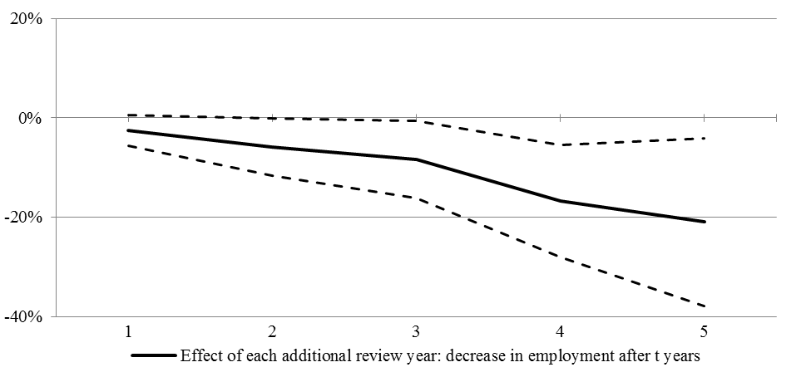

Panel B. Sales growth.
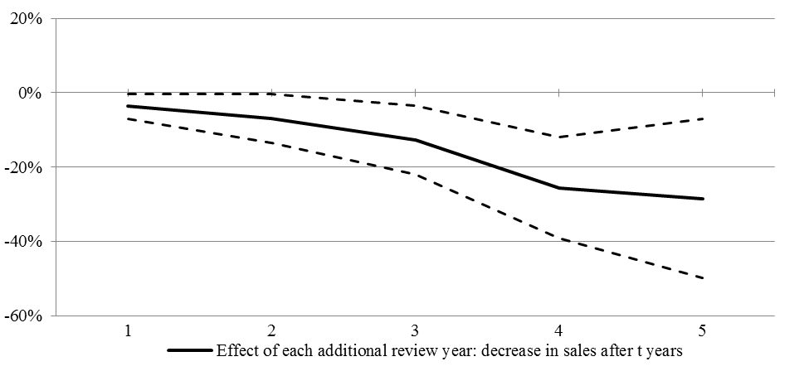

Figure 4, Panel A, shows that for each year of delay in the patent application process, employment growth declined by 2.4% in the first year after a patent grant, and by 12.7% and 19.3% over three and five years, respectively. Figure 4, Panel B, shows that “[s]ales growth exhibits a similar negative post-decision trend,” with each year of delay causing sales growth to slump by 3.6%, 12.8%, and 28.4% over the one, three, and five years following the patent first-action decision.

This study also found that each additional year it takes the USPTO to review an application reduces the startup’s subsequent probability of going public, by as much as a half. In fact, according to Farre-Mensa, “[e]conomically, a two-year delay has the same negative impact on a startup’s growth and success as outright rejection of the patent application.”

The Economic Impact of Uncertainty in Patent Rights

A new disclosure requirement could lead to uncertainty not only in the patent application process but also in patent rights, which can affect a firm’s overall market competitiveness. This section examines the economic impacts of uncertainty in patent rights with respect to a firm’s licensing agreements, research and development (R&D) investment, and litigation.

“The idea that patent protection increases a firm’s ability to appropriate the returns from its innovations is commonplace in the literature.” Illustrating the economic importance and perceived market value of patent protection is a study by Joshua Gans drawn from a sample of nearly 200 technology licensing deals between startup innovators and downstream firms across four industry sectors. For each deal, the study gathered the license date announcement, the deal industry sector, firm location and age. For each patent-license pair, detailed patent information was collected from the USPTO and the National Bureau of Economic Research (NBER) patent data file, as well as venture capital (VC) financing information from the Venture Economics database.

Comparing the dates of patent licenses with those of the associated patent allowances, the study found “a striking linkage between the timing of patent allowance and licensing agreements.”

Gans, Figure 2, reproduced below, is illustrative:

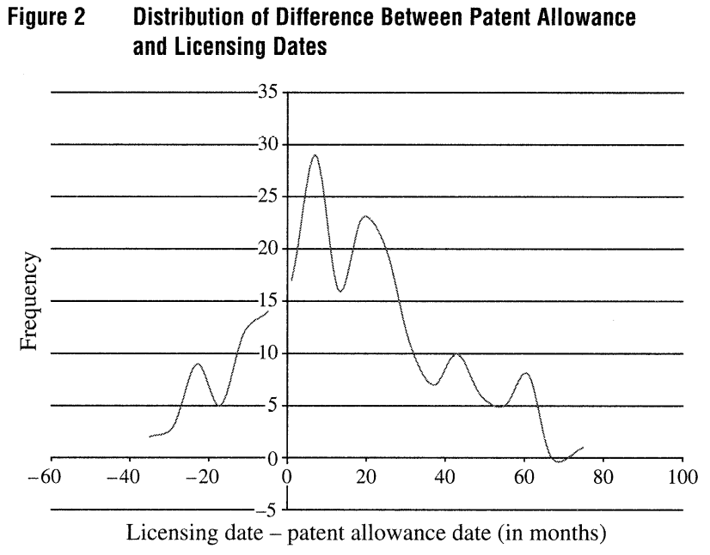

Figure 2 plots the distribution of the difference between patent allowance lag and licensing lag. Data to the left of zero are associated with licensing deals reached prior to patent allowance, whereas data to the right of zero indicate post-allowance licensing.

Importantly, Figure 2 shows a marked increase in the level of licensing right around the time the patent was allowed. If the new disclosure requirements are adopted, however, patent applications and patents that are subject to new disclosure requirements could be delayed, reducing the likelihood of licensing. Also, these patent applications and patents could have a lower market value due to the threat of disclosure-based rejections and post-grant challenges. Indeed, a previous study by Gans “found that start-up firms are more likely to license (or be acquired) if they have one or more patents or if they rate patent protection as being relatively ‘effective.’ But . . . when patent protection is ineffective[] because . . . unclear patents make enforcement uncertain, then licensing is less likely to occur.”

“Private investors will not be inclined to invest in the production of knowledge unless they see an opportunity to. . . earn an adequate return on investment.” Accordingly, uncertainty about future market returns plays a critical role in the decision to invest in R&D. A study led by Dirk Czarnitzki shows that the level of current R&D investment falls as the degree of uncertainty about returns to innovation increases. Czarnitzki surveyed 566 product-innovating firms over several years using, among other sources, the Mannheim Innovation Panel (MIP) (a long-standing European business survey) and firm-level patenting data from the German Patent and Trademark Office. In both pooled- and random-effects models, Czarnitzki found that uncertainty in new product markets significantly reduces current firm-level R&D investment. For example, when the pooled model B was used, Czarnitzki found a 10% increase in uncertainty led to a reduction of R&D investment by 23%.

Although Czarnitzki also found that patent protection mitigates the influence of uncertainty on the firm’s R&D decision, “when patenting is not an effective means of protection, it cannot mitigate the effect of product market uncertainty.” In other words, a patent whose value is uncertain—e.g., due to the new disclosure requirement—likely would not mitigate the influence of uncertainty on a firm’s R&D decision.

Czarnitzki’s study suggests that in the face of uncertainty, firms are more likely to forgo the R&D necessary to invent and secure patents. As a result, firms may have to rely on weaker and non-disclosed forms of intellectual property protection, such as trade secrets. Worse yet, firms may decide to innovate less and instead rely on others’ research, to the detriment of scientific and industrial development. As the United States has stated previously “[n]ew disclosure requirements create uncertainties in the patent system that discourage research and development, the use of the patent system and the corresponding publication of inventions that may otherwise remain in confidence.”

Finally, a presumption of patent validity is critical for the licensing and enforcement of patents. Where the sanctions for non-compliance with a new patent disclosure requirement include invalidation of a patent, a “cloud” of uncertainty may be created over a patent right by opening a new avenue for litigation, thus decreasing the value of the patent.

Conclusion

The United States has significant economic-based concerns about proposals for new patent disclosure requirements that are under consideration in the WIPO IGC. These requirements will cause uncertainty in the patent system that, at best, will raise costs for innovators, IP offices, and the public, and at worst, will chill and deter innovation and public disclosures of inventions, to the detriment of scientific, technological and economic development around the world. The U.S. remains unconvinced that any purported benefits from new patent disclosure requirements being considered in the IGC would outweigh the real and significant harm they might impose. There is a lack of evidence in support of economic benefits or value from new patent disclosure requirements. Rather, the evidence suggests that new patent disclosure requirements might negatively impact the patent system, which has functioned for hundreds of years in many parts of the world to the benefit of societies at large. As a consequence, new patent disclosure requirements would have a negative impact on economic development. Accordingly, the United States urges the use of caution when exploring these proposals.

[End of Annex and of document]

World Intellectual Property Organization, Consolidated Document Relating to Intellectual Property and Genetic Resources, WIPO/GRTKF/IC/36/4, 10–11 (2018), http://www.wipo.int/edocs/mdocs/tk/en/wipo_grtkf_ic_36/wipo_grtkf_ic_36_4.pdf (accessed June 19, 2018).
Id.
Id. at 12.
Dominic Keating, The WIPO IGC: a U.S. Perspective, in Protecting Traditional Knowledge: The WIPO Intergovernmental Committee on Intellectual Property and Genetic Resources, Traditional Knowledge and Folklore at 270 (Daniel F. Robinson, Ahmed Abdel-Latif, and Pedro Roffe eds. 2016).
Id.
Keating, supra n.4 at 271.
Pertinent economic definitions of uncertainty include “a lack of confidence in a belief with different degrees (high-low),” “a lack of foreknowledge which is relevant to make decisions,” and “a lack of information which is relevant to make decisions.” Irene Troy, Patent Transactions and Markets for Patents, Dealing with Uncertainty, Doctoral Thesis, Utrecht University 18, 80 (2012).
Queen Mary Intellectual Property Research Institute, Report on Disclosure of Origin in Patent Applications for the European Commission, DG-Trade 61 (2004), http://trade.ec.europa.eu/doclib/docs/2005/june/tradoc_123533.pdf (accessed June 19, 2018) [hereinafter EC Report 2004].
See id. at 68.
WIPO 2005, supra n.8 at 46; see EC Report 2004 at 76, “[t]he more broad and complex the requirement, the greater is the uncertainty.”
World Intellectual Property Organization, Intergovernmental Committee on Intellectual Property and Genetic Resources, Traditional Knowledge and Folklore, Draft Report, WIPO/GRTKF/IC/23/8 PROV. 2, 26 (2013), http://www.wipo.int/edocs/mdocs/tk/en/wipo_grtkf_ic_25/wipo_grtkf_ic_25_ref_grtkf_23_8_prov_2.pdf (accessed June 19, 2018) [hereinafter WIPO 2013).
Id.
Id.
See Claudio Chiarolla and Burcu Kiliç, Developing Patent Disclosure Requirements Related to Genetic Resources and Traditional Knowledge – Key Questions, World Intellectual Property Organization 24, 88–89 (2017), https://ssrn.com/abstract=2987820 (accessed June 19, 2018); see also See WIPO 2005, supra n.13 at 51, suggesting that without uniform and predictable procedures in place to submit and process the disclosure, patent examiners may have trouble verifying information provided by applicants.
Joan Farre-Mensa et al., The Bright Side of Patents, USPTO Economic Working Paper No. 2015-5 Abstract (2015), https://www.uspto.gov/sites/default/files/documents/Patents%20030216%20USPTO%20Cover.pdf (accessed June 19, 2018); see also Joshua S. Gans et al., The Impact of Uncertain Intellectual Property Rights on the Market for Ideas: Evidence from Patent Grant Delays, 54(5) Mgmt. Sci. 984, “innovators face significant opportunity costs if they delay commercialization while applications are pending.”
Farre-Mensa, supra n.18 at 2.
Id. at 3–4, 10.
Id. at 20, 40.
Id. at 40.
Farre-Mensa, supra n.18 at 40.
Id. at 20.
Id. at 20, 22.
Id. at 22–23.
Farre-Mensa, supra n.18 at 3, 23, 47 (Table 7).
Id. at 3.
Dirk Czarnitzki and Andrew A. Toole, Patent Protection, Market Certainty, and R&D Investment, 93(1) The Review of Economic and Statistics 147 (2011).
Gans, supra n.18 at 989.
Id.
Id.
Id. at 990.
Gans, supra n.18 at 990.
Id.
James Bessen and Michael J. Meurer, Patent Failure, How Judges, Bureaucrats, and Lawyers Put Innovators at Risk 185 (Princeton Univ. Press 2008), citing Gans, Hsu, and Stern, When does start-up innovation spur the gale of creative destruction?, 33(4) RAND Journal of Economics 571–586 (2002).
Irene Troy and Raymond Werle, Uncertainty and the Market for Patents, Max Planck Institute for the Study of Societies, MPlfG Working Paper 08/2, 9 (2008).
Czarnitzki, supra n.29 at 148.
Id.
Id. at 149.
Id. at 152.
Czarnitzki, supra n.29 at 153.
Id. at 155.
Cf. Edson Beas Rodrigues Jr., Property rights, biocultural resources and two tragedies: Some lessons from Brazil, in Genetic Resources and Traditional Knowledge, Case Studies and Conflict Interests 148–150 (Tania Bubela and E. Richard Gold eds. 2012) (noting that laws aimed at protecting biological resources in developing countries have hindered the conduct of scientific activities and have chilled interest in the productive and scientific sectors to research them).
WIPO 2005, supra n.8 at 40.

