
PRESS RELEASE

UNCTAD/PRESS/PR/2013/16
Original: English

TRADE IN CREATIVE PRODUCTS REACHED NEW PEAK IN 2011,
UNCTAD FIGURES SHOW

Numbers released in run-up to Global Services Forum in Beijing
show creative industries exports rose sharply from 2002-2011

Geneva, 15 May 2013 – World trade in creative goods and services totaled a record US$624 billion in 2011, up from $559.5 billion in 2010, according to the UNCTAD Global Database on the Creative Economy.

Global exports of such goods and services as arts and crafts, books, graphic and interior design works, fashion, films, music, new media, printed media, visual, as well as audiovisuals, picked up in 2011 – the latest year for which figures are available -- from $536 billion in 2009 and $559 billion in 2010. The sector has now exceeded its pre-crisis peak of $620.4 billion in exports in 2008. The minor decrease in the overall consumption of creative products after 2008 reflected the fragility of the post-crisis recovery in developed countries mainly due to the rise of public deficits, currency volatility, and high levels of unemployment, especially in the most advanced countries, UNCTAD economists say.

Released in advance of the 28-29 May Global Services Forum in Beijing, the figures show that creative services exports (as opposed to creative goods) jumped to $172 billion in 2011, up from $163.8 billion in 2010, and a near tripling in terms of value from the 2002 total of $62 billion. Part of that increase reflects the trend in which more governments are compiling statistics on the creative economy. Architecture and related services, cultural and recreational services, audiovisual services, advertising, and research and development services are the core activities comprising creative services. As the knowledge-based economy expands around the globe, creative services continue to grow, UNCTAD officials say.

The Global Services Forum (GSF) is organized by UNCTAD together with the Ministry of Commerce of China and the Government of Beijing Municipality.

Overall, global trade in creative products more than doubled from 2002 to 2011. The average annual growth rate during that period was 8.8 per cent. UNCTAD creative-economy statistics are based on official national data provided by governments.

Growth in developing country exports was stronger still, averaging 12.1 per cent annually for the period. Such exports of creative goods and services reached $227 billion in 2011, or 50 per cent of the global total. China remains the leading exporter of creative goods. Its creative-products exports tripled from $32 billion in 2002 to $125 billion in 2011, an annual growth rate of 14.7 per cent. China’s exports not only reflect its ability to create, produce, and trade a mixture of traditional and high-tech creative products but also the fact that many creative goods produced and exported by China are created or designed in other countries.

Overall, however, there are very few developing countries among the top 20 global players in the world market for creative goods, UNCTAD notes.
Demand for most creative industry products and services -- particularly those which are domestically consumed, such as interior design products, videos, music, video games, and new formats for TV and radio broadcasting -- remained strong through the first decade of the century and were more resilient than other economic sectors during the global financial crisis and recession.

UNCTAD officials say the prospects for continued growth are good, as the creative economy reflects contemporary lifestyles increasingly associated with social networking, innovation, connectivity, style, status, brands, cultural experiences, and co-creations.

Domestic demand for creative products has increased in recent years in the emerging economies of Asia, Latin America, and Africa, the statistics show, although the trend has not extended to North Africa and some countries in West Asia, where political unrest has adversely affected the levels of growth, trade, and tourism. Before the recession, the global market had been boosted by increases in “South-South” trade in creative products.

Design -- functional creations that deal with forms, specifications, and the appearance of goods -- is the largest contributor to trade in creative industries. In 2011, some $301 billion of design goods entered into the global market, accounting for over 66 per cent of total exports of creative goods. Interior design products, fashion, and jewelry were the key sectors.

New media has been the faster growing creative sector in recent years, the statistics show. The level of exports has grown by 13.8 per cent annually, reaching a peak in 2008 of $54 billion.

Publishing and printed media, which include books and all kinds of news circulated as newspapers, magazines, etc., is a sector facing challenges due to the explosion of electronic publishing and distribution, but trade flows nonetheless amounted to $43 billion in 2011.

The global market for visual arts is another multi-billion dollar business characterized by fierce competition and the potential for huge commercial gains. In times of instability in financial markets, the art market usually rebounds. In 2011, trade in that sector reached $31 billion, topping the2008 total of $30 billion. The global total had fallen to $26 billion in 2010. Attention also should be draw to the fact that the market for art crafts is significant. It increased from $17.5 billion in 2002 to over $34 billion in 2011.

Meanwhile, rapid advances in digital technologies and information and communication technology (ICT) tools combined with shortcomings in methodology make it increasingly difficult to capture trade flows or to compile reliable figures for music as a physical creative good (such as CDs and tapes). That is because most of world music is now commercialized on-line in digital form for which official data at global level is unavailable. The same applies for e-videos, e-films, e-books, e-news, e-advertising, etc. With current technology, local music now can reach global audiences instantaneously through new business models that are democratizing and unlocking the creation, production, marketing, and distribution of music goods and services. But the absence of data for copyrighted trade flows and the obscurity of intra-firm transactions are impediments to the analysis of the changing world music market.

UNCTAD data are indicative of trends; hence the actual figures can be considerably higher. In addition to the charts and tables provided below, country profiles on trade in creative products can be derived from the UNCTAD Global Database on the Creative Economy at http://www.unctad.org/creative-programme or http://unctadstat.unctad.org.

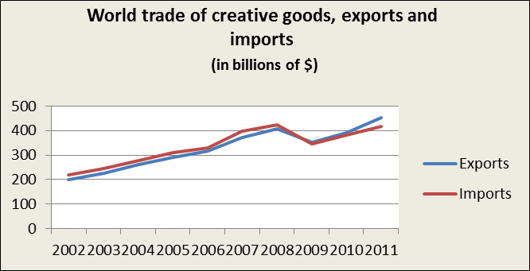

Source: UNCTAD, based on official data in UN COMTRADE database

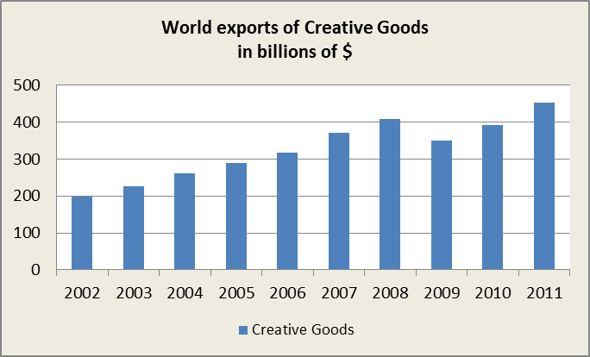

Source: UNCTAD, based on official data in UN COMTRADE database

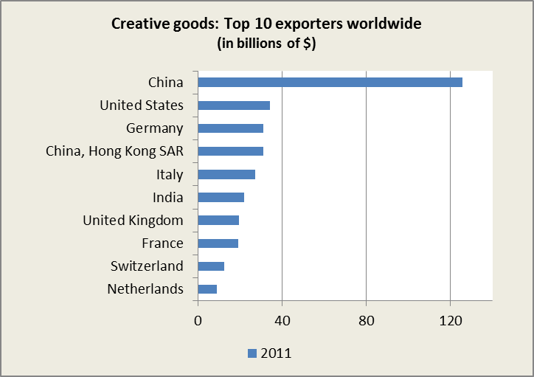

Source: UNCTAD, based on official data in UN COMTRADE database

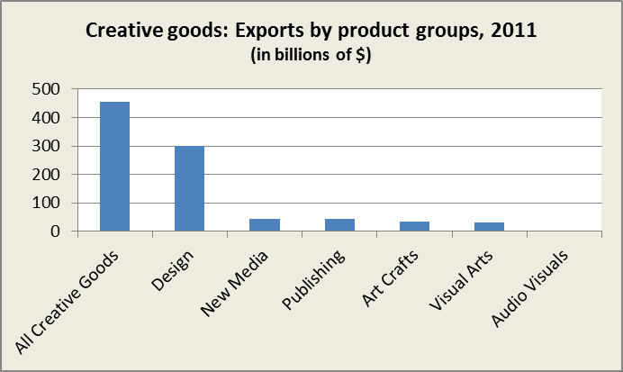

Source: UNCTAD, based on official data in UN COMTRADE database

Creative goods: Exports, by economic group, 2002 and 2011
(in millions of $)
 | World |  | Developed economies |  | Developing economies |  | Transition economies
 | 2002 | 2011 | 2002 | 2011 | 2002 | 2011 | 2002 | 2011
All Creative Goods | 198'240 | 454'019 | 73'890 | 227'867 | 1'181 | 3'555 | 123'169 | 222'597
Art Crafts | 17'503 | 34'209 | 8'256 | 10'653 | 9'201 | 23'383 | 45 | 172
Audio Visuals | 455 | 492 | 417 | 400 | 35 | 90 | 3 | 2
Design | 114'694 | 301'262 | 60'970 | 127'239 | 53'362 | 172'223 | 362 | 1'800
New Media | 17'506 | 43'744 | 13'071 | 28'918 | 4'412 | 14'607 | 23 | 219
Performing Arts | 2'754 | - | 2'478 | - | 250 | - | 26 | -
Publishing | 29'908 | 43'077 | 26'061 | 33'650 | 3'157 | 8'106 | 690 | 1'321
Visual Arts | 15'421 | 31'127 | 11'916 | 21'631 | 3'474 | 9'456 | 31 | 40

Source: UNCTAD, based on official data in UN COMTRADE database

Creative goods: all creative industries exports of South-South trade, by regional group and China, 2002 and 2011
(in millions of $)
 | África |  | América |  | Asia
 | 2002 | 2011 | 2002 | 2011 | 2002 | 2011
All Developing economies | 986 | 5'564 | 2'310 | 10'747 | 14'082 | 79'757
Africa | 122 | 633 | 5 | 35 | 40 | 482
America | 11 | 84 | 741 | 2'635 | 53 | 89
Asia | 853 | 4'847 | 1'564 | 8'078 | 13'987 | 79'185
China | 388 | 3'570 | 732 | 6'563 | 7'305 | 37'156

Source: UNCTAD, based on official data in UN COMTRADE database

*** ** ***

* Contacts: UNCTAD Communications and Information Unit, +41 22 917 58 28, +41 79 502 43 11, unctadpress@unctad.org, http://unctad.org/en/pages/Media.aspx

