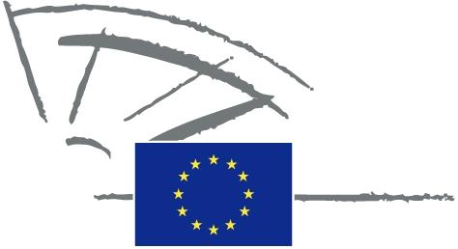
 | EUROPEAN PARLIAMENT | 2009 - 2014

<Date>{09/02/2010}</Date> <NoDocSe>/2010</NoDocSe>
<TitreType>WRITTEN DECLARATION</TitreType>
<TitreRecueil>pursuant to Rule 123 of the Rules of Procedure</TitreRecueil>
<Titre>on the lack of a transparent process and potentially objectionable content concerning the Anti-Counterfeiting Trade Agreement (ACTA)
Françoise Castex, Zuzana Roithova, Alexander Alvaro, Stavros Lambrinidis
</Titre>
Lapse date: <DateForclusion>{}.2010</DateForclusion>
00/2010
Written declaration on the lack of a transparent process and potentially objectionable content concerning the Anti-Counterfeiting Trade Agreement (ACTA)
The European Parliament,

– having regard to Rule 123 of its Rules of Procedure,
A. Whereas the ongoing negotiations concerning the Anti-Counterfeiting Trade Agreement (ACTA).
B. Whereas the co-decision role of the European Parliament in commercial matters and its access to negotiation documents guaranteed by the Lisbon Treaty,

1. Considers that the proposed agreement should not indirectly impose harmonisation of EU copyright, patent or trademark law. The principle of subsidiarity should be respected,
2. Declares that the Commission should immediately make all documents related to the ongoing negotiations publicly available.

3. Takes the view that the proposed agreement should not force limitations upon judicial due process nor weaken fundamental rights such as freedom of expression and the right to privacy.
4. Stresses that the evaluation of economic and innovation risks must take place prior to introducing criminal sanctions where civil measures are already in place.
5. Considers that Internet service providers should not bear liability for the data they transmit or host through their services to an extent that would imply prior surveillance or filtering of such data.
6. Points out that any measure aimed at strengthening powers for cross-border inspection and seizures of goods should not harm global access to legal, affordable and safe medicines.
7. Instructs its President to forward this declaration, together with the names of the signatories, to the Commission, the Council and the parliaments of the Member States.

